

**Faculty Senate Meeting**

**Thursday, October 17th, 2024**

**12:00–3:00 p.m.**

**Zoom Video Conference (**[**https://cusystem.zoom.us/j/94808817207**](https://cusystem.zoom.us/j/94808817207))

[**Faculty Council**](https://www.cu.edu/faculty-council)

**Meeting Minutes**

**Attending:** Alastair Norcross (Chair, UCB), Jorge Chavez (Vice Chair, UCD), Vicki Grove (Secretary, ), Steve Cass (AMC), Adam Norris (UCB), Anna Kosloski (UCCS), Michael Lightner (SYS, VP, Academic Affairs), Anne Fleming (SYS, FSGC), Carlos Reali (UCD), Cindy O’Bryant (AMC), Deb Kenny (AMC), Diana White (UCD), Erin Hauger (UCD), Esther Lamidi (UCCS), Greg Kinney (AMC), Jay Dedrick (SYS), Joel Tonyan (UCCS), Karen Markel (UCCS), Laura Rosenthal (UCCS), Leigh Holman (UCB), Madiha Abdel-Maksuod (AMC), Maureen Durkin (SYS, Director for Academic Program and Policy Analysis, Academic Affairs), Norah Mazel (UCCS), Ravinder Singh (UCB), Sasha Breger Bush (UCD), Sloan G. Speck (UCB), Suzanne Cook (UCCS), Maria Lewis (SYS, Faculty Council Administrator), Jacqueline Nolly (SYS, Recording Secretary), Todd Saliman (SYS, University President), Valerie Simmons (SYS, VP of Compliance and Equity, Title IX coordinator), Kathy Shaw (AMC), Jeffrey Shrader (UCD)

1. **12:00 p.m. Call to Order & Approval of April Faculty Senate Meeting Minutes**
   1. Motion to approve minutes; seconded; Minutes approved
2. **12:00-12:10 p.m. Faculty Senate Grievance Committee Chair, Steve Cass**
   1. Summary of case activity: 11 faculty members; reviewed and if accepted; sent to a panel of 6 faculty members, then sent to chancellor
   2. Violations of faculty rights; nonrenewal, etc
      1. 1 dismissal for cause under review
      2. 4 cases investigated
      3. 2 still in progress
   3. FS bylaws - FSGC sent out to legal for review will come back to FC for their own revision of bylaws
   4. Creating internal documents to outline internal processes to ensure consistency in future cases and membership transitions
   5. Reminder about spring membership requests and any trends in the types of cases coming to FSGC
3. **12:10 -12:30 p.m. Faculty Council Chair’s Report—Alastair Norcross**
   1. Bylaws Update
      1. To include more detailed descriptions of the duties for officers
      2. More detailed description of the roles of FSGC
   2. Constitution Approval
      1. 10% response rate needed from each campus (per new guidelines)
      2. Reminder with a link to vote will be sent out on Monday
   3. Faculty Council retreat
      1. Think about topics of interest and notify organizers if there are any particular topics of interest
   4. Discussion of sick leave
      1. Available under MyLeave for some campuses
      2. Sick leave can be lost if an employee switches campuses
      3. 11 days a year applies to all campuses now
         1. Do they expire?
         2. Is there a maximum amount?
         3. Do they transfer?
4. **12:30-1:00 p.m. President’s Report–Todd Saliman**
   1. State funding and budget - getting ready for the next legislative session
   2. A special session was recently convened to address initiatives 50 and 108
      1. Compromised measure provides some relief to property owners but does not drastically cut funding to higher education
      2. Will have an impact on next year’s budget
         1. Internal forecast predicts modest growth for state and higher ed next year, which will make next year’s financial planning and budget a challenge
   3. Current projections (nationally) predict inflation to be modest over the next few years
      1. Will this discussion about inflation also register in CU’s documents about fundraising? https://www.cu.edu/doc/bormfsfundraisingpdf
      2. Numbers might not match up once actual (not predicted) inflation rates are accounted for
      3. Actual inflation rates have less impact on donor amounts
   4. Will be lobbying for funds to cover compensation increases but the primary source for compensation will be drawn from tuition revenue
      1. Scheduled for January 1
      2. State budget accounts for compensation increases for all state employees except for higher ed
      3. How the university handles compensation issues impacts its ability to recruit talent in a competitive environment
         1. Benchmark salary info from other campuses compound this issue
   5. Academic free speech and recently drafted resolution
      1. Regent Policy 1D (“Freedom of Expression”) is listed in a draft form at the top of the Regent Laws and Policies Review page. <https://www.cu.edu/regents/rlpreview>
      2. State and institutional policies already exist that outlines protected speech and when speech acts constitute hate acts
      3. Perceived discrimination still mandates reporting, even if it falls short of hate crime criteria
      4. Current Regent policy already clarifies who can speak on behalf of the University and under what circumstances
   6. Digital Accessibility
      1. New digital accessibility requirements that went into effect this year and each campus has a dedicated office to ensure compliance
      2. System wide working committee provides oversight
      3. At Anschutz, <https://www.cuanschutz.edu/accessibility/digital-accessibility>
      4. Precipio training: “*digital accessibility training is live on the Percipio platform. To access the training, go to MyCUInfo, choose the training tile/link, and then select [Skillsoft] Percipio from the options. Once in Percipio, you can search for the training by name or type in “accessibility.” Please let us know if you have any questions. Please feel free to share this with your colleagues across the CU System.”*
      5. Questions from the chat: If I recall correctly, the new state law includes a provision about state bodies being able to make budgetary requests in order to meet the requirements of digital accessibility. Is CU requesting extra budget funding to meet the requirements? Is any extra funding bolstering the accessibility?
         1. Is the system providing financial resources to the campuses to hire essential accessibility-related staff and/or stand up Accessibility offices?
5. **1:15-1:30 p.m. New Portal & HCM Features–RyAnne Scott, Director of Communication & Outreach** 
   1. New self-service feature available in the employee portal allows for the selection of gender identity
      1. Twelve options will be available
      2. As these features roll out, there will be a way for individuals to provide feedback
      3. Resources for how to coordinate with local HR under legal sex status change will also be available
      4. This will allow a more accurate reflection of workforce representation
      5. 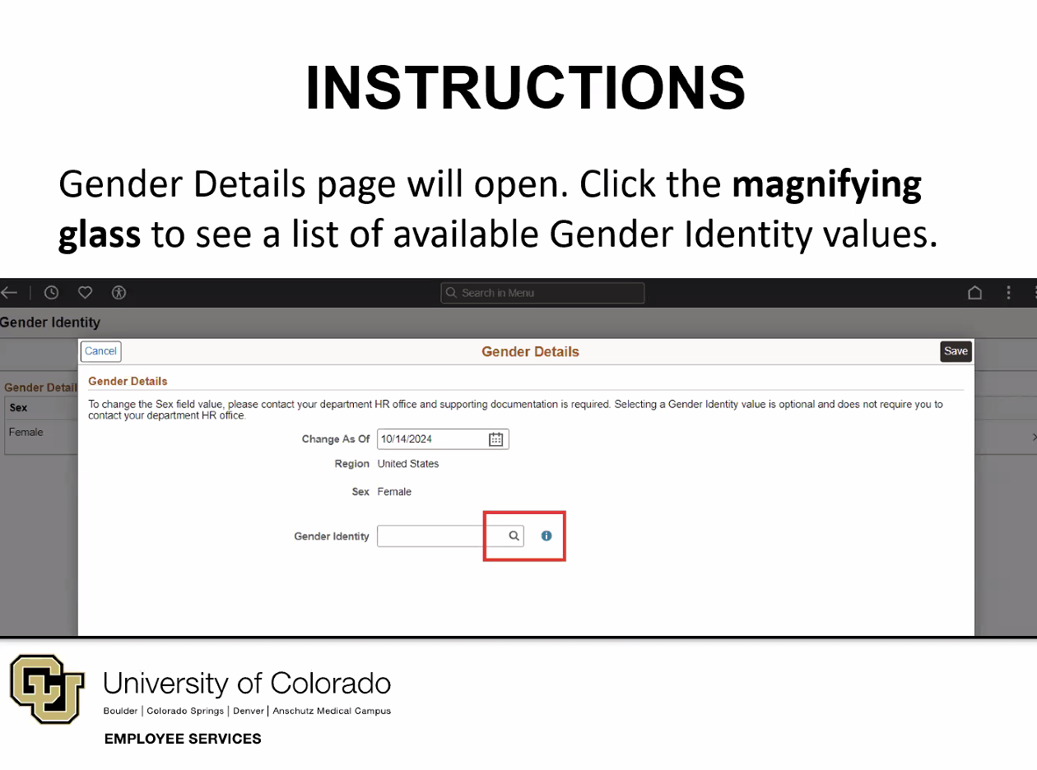
      6. 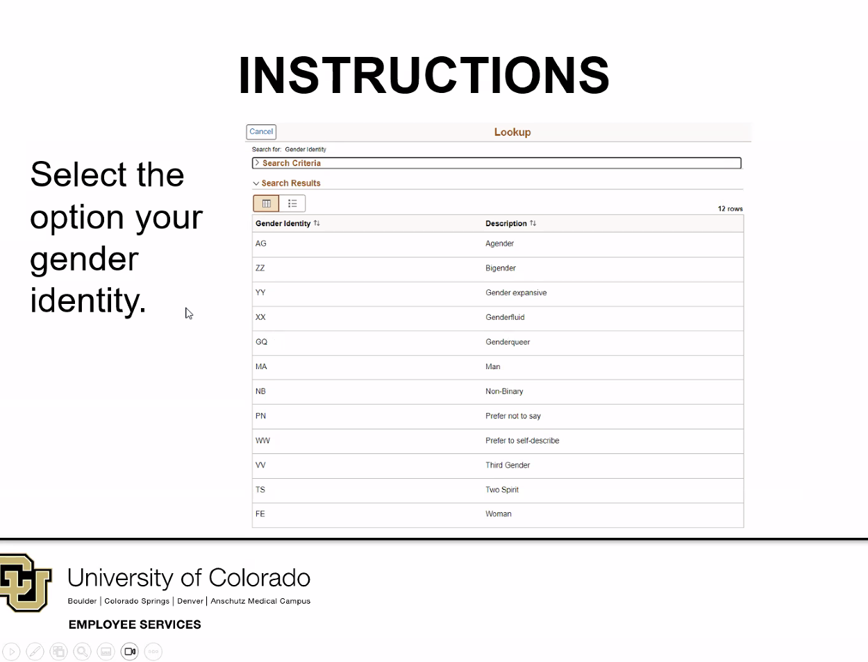
      7. People with access to HCM will be able to see this data; other people may also have access but University privacy policies apply to everyone to secure individual privacy
         1. Information will not be searchable to HCM users
   2. OIT and retired faculty permissions
6. **1:30-1:45 p.m. Academic Affairs Update with VP Michael Lightner** 
   1. Maintaining an effort to de-gender Regent laws and policies
   2. Boarddocs will be replaced by community (by Diligent, the same company that produced Boarddocs)
      1. <https://cu.diligent.community/Portal/MeetingInformation.aspx?Org=Cal&Id=524>
   3. If the documents are off CU servers, and instead held by a third party, does that have implications for CORA?
   4. Reduced credit bachelor's degree; current accreditor considering how it would fit into current rules
      1. Department of Higher Ed did look into whether one could be approved and found that it could not be approved
      2. Even if it does overcome obstacles and can get passed, it will have a different designation than other bachelor degrees
      3. CRS §23-1-125 (on page 66 of the 777-page PDF file) may be the passage Mike referred to with the 120 hours for a baccalaureate degree. <https://leg.colorado.gov/sites/default/files/images/olls/crs2023-title-23.pdf>
7. **1:45-2:00 p.m. Campus Faculty Assembly Updates** 
   1. Anschutz – Greg Kinney, Chair
      1. Restructuring to increase participation in shared governance; issue with retired faculty accessing outlook points to larger issues with IT; reduced credit degree will impact eligibility for certain programs at AMC by omitting prerequisites; pockets of the campus, or parts of AMC, aren’t as uniform with accessibility standards so an effort is being made to ensure compliance and standard practices
   2. Boulder – Shelly Miller, Chair
      1. FCQ revision committee will convene over the next two weeks; BFA priorities and action items identified and narrowed down to 4 items for working groups AI, climate change, budget and planning; compensation;revising bylaws to feature new officer structure; new policy on lecturers and instructors; goal is to have new provost by the end of spring
      2. OIT: the boulder faculty is getting actively involved in how decisions are made and making sure faculty are consulted early and often
   3. Colorado Springs – Joel Tonyan, President
      1. The prospect of reduced credit hour degrees became a topic of discussion, many faculty perceive it to be fraught with concerns; the provost search is under way and 120 applications have been narrowed down to 6 candidates (that will hopefully be invited to campus in November); Professional Rights and Responsibilities and Grievance policies under review and revision; campus proposal to lease university land for 50-99 yrs for the purpose of a hotel/conference center generated concern; recruited a faculty member to join the system FC PB committee.
   4. Denver – Sasha Breger-Bush, Chair
      1. Leadership transition on campus has stalled progress on a number of fronts; search for new chancellor is ongoing, recommendations have been made to Pres. Saliman, and will hopefully be ready to announce by Thanksgiving; AHEC topic/master plan framework for commercial campus development, will include IPG, a group consisting of faculty, students, as well as displaced residents; IPG still struggling with gathering the necessary information required to assess risks - especially concerning ball park development; FCQ working group is making excellent headway in the reduction of systemic bias and preventing data mining.

1. **2:00-2:30 p.m. Faculty Council Committee Updates** 
   1. Budget & Finance – Diana White, Chair
      1. Still need to recruit more members; the low member count is presenting a challenge
   2. Communication – Laura Rosenthal, Chair
      1. Two new members from Denver;
      2. Working on the publication of the upcoming newsletter to be distributed in December
      3. Looking for faculty involvement for FV
   3. CREE – Carlos Reali / Thomas Beck, Co-Chairs
      1. Also struggling to reach quorum due to low membership; trying to gain traction via email
   4. EPUS – Ravinder Singh, Chair
      1. 1022 was sent out for feedback from campuses; will meet with FC chair to determine what actions will be taken next; not yet a motion that the FC will need to vote on yet
   5. LGBTQ+ – Carey Candrian / Troyann Gentile, Co-Chairs
      1. Concerned with recent DEI changes at UCCS
      2. FAMLI–dependents not being explicitly listed (on accident, but crucial specification needed)
      3. RyAnne Scott scheduled to join next meeting in light of HCM changes
      4. Look at “best practices” for HR in re: employee relations and diverse faculty
   6. Personnel & Benefits – Jeffrey Schrader, Chair
      1. Change to the medicare enrollment plan
      2. <https://www.cu.edu/employee-services/medicare-fall-enrollment>
      3. Looking into benefits for retired faculty
      4. Investigating whether there is a mechanism to reinstate housing benefits for IRC
   7. Women – Anna Kosloski / Esther Lamidi, Co-Chairs
      1. Vacancies: 1 from AMC and 2 from Denver
2. **3:00 p.m. New Business**
   1. FC Retreat
   2. Fall Break

**Next Meeting: November 21st, 2024**